- Copyright for test papers and marking guides remains with West Australian Test Papers.
- The papers may only be reproduced within the purchasing school according to the advertised conditions of sale.
- Test papers must be withdrawn after use and stored securely in the school until Wednesday 15th October 2014.

PHYSICS

YEAR 12

STAGE 3

2014

SOLUTIONS



Name: _______________________________________________________

Teacher: ___________________________________________________

TIME ALLOWED FOR THIS PAPER

Reading time before commencing work: Ten minutes
Working time for the paper: Three hours

MATERIALS REQUIRED/RECOMMENDED FOR THIS PAPER

To be provided by the supervisor:
- This Question/Answer Booklet; Formula and Constants sheet

To be provided by the candidate:
- Standard items: pens, pencils, eraser or correction fluid, ruler, highlighter.

- Special items: Calculators satisfying the conditions set by the Curriculum Council for this subject.

IMPORTANT NOTE TO CANDIDATES

No other items may be taken into the examination room. It is your responsibility to ensure that you do not have any unauthorised notes or other items of a non-personal nature in the examination room. If you have any unauthorised material with you, hand it to the supervisor before reading any further.

Structure of this paper

Section | Number of questions available | Number of questions to be answered | Suggested working time  (minutes) | Marks available | Percentage of exam
Section One:  Short answer | 13 | 13 | 50 | 54 | 30
Section Two:  Extended answer | 7 | 7 | 90 | 90 | 50
Section Three:  Comprehension  and data analysis | 2 | 2 | 40 | 36 | 20
 |  |  | Total | 180 | 100

Instructions to candidates

- The rules for the conduct of Western Australian external examinations are detailed in the Year 12 Information Handbook 2013. Sitting this examination implies that you agree to abide by these rules.

- Write answers in this Question/Answer Booklet.

- When calculating numerical answers, show your working or reasoning clearly. Give final answers to three significant figures and include appropriate units where applicable.

When estimating numerical answers, show your working or reasoning clearly. Give final answers to a maximum of two significant figures and include appropriate units where applicable.

- You must be careful to confine your responses to the specific questions asked and follow any instructions that are specific to a particular question.

- Spare pages are included at the end of this booklet. They can be used for planning your responses and/or as additional space if required to continue an answer.
  - Planning: If you use the spare pages for planning, indicate this clearly.
  - Continuing an answer: If you need to use the space to continue an answer, indicate in the original answer space where the answer is continued, i.e. give the page number. Refer to the question(s) where you are continuing your work.

Section One: Short response 30% (54 Marks)

This section has 13 questions. Answer all questions. Write your answers in the space provided. Suggested working time for this section is 50 minutes.

Question 1
A straight wire of length 250 mm carries a current of 4.50 A and is placed in a uniform magnetic field. The wire experiences an electromagnetic force of 5.48 x 10⁻² N. Calculate the magnitude of flux density perpendicular to the wire.
(2)
l = 0.250 m I = A F = 5.48 x 10⁻² N

F = BIl

B = F / Il = 5.48 x 10⁻² / (4.50 x 0.250) ✓
B = 4.87 x 10⁻² T ✓

Question 2
An ice hockey puck slides at 21.0 m s⁻¹ South-West, hits a goal post and rebounds at 20.0 m s⁻¹ North-West. Calculate the change in velocity of the ice hockey puck. You must refer to a vector diagram and state both magnitude and direction in your response.
(4)

-u = 21 North East
v = 20 North West
θ°
Δv = v + (-u)
Δv = v + (-u) as shown in 2D diagram ✓
= 29.0 m s⁻¹ ✓ 
➔ = tan⁻¹(21/20) ✓ = 46.4° = true bearing 1.40° or N 1.40° E ✓

Question 3

Potential =
Negative
Potential =
Positive
Potential =
Negative
(1)

The metal rotor blades of a helicopter are shown in the diagram as viewed from above. The helicopter is in Perth where the Earth’s magnetic field points upwards with an angle of dip of 66° to the horizon.
The blades are turning clockwise.

- Identify areas of positive or negative electric potential as indicated in the diagram.
✓

- Explain how a potential difference is established in this situation.
(3)
Charge within the blades is moved in the direction of the arrows through the Earth’s magnetic field. ✓ In Perth the component of the field acting upwards from the ground interacts with the circular field established by the moving charges. ✓
Delocalised electrons are pushed to the rotor tips giving them a net negative charge. This leaves a net positive charge at the centre. ✓
Or similar

Question 4
The diagram shows object A falling at a constant speed of 2.00 m s⁻¹ towards the ground and object B accelerating at 9.80 m s⁻² towards the ground. What is the acceleration of object B relative to object A? Explain briefly.
(3)
Object A, v = 2.00 m s⁻¹
Object B, a = 9.80 m s⁻²
In the frame of reference of the ground the acceleration of A = zero and B = 9.80 m s⁻² down. ✓

In terms of acceleration the reference frame of the ground and object A is the same. They have no acceleration in each other’s reference frame. ✓

Therefore the acceleration of object B relative to A is 9.80 m s⁻² down. ✓

Question 5
20.0°
Mass m
1.50 m
Speed v
Radius r
A ball of mass m, suspended from a ceiling moves along a horizontal circle of radius r at a constant speed v. The string connecting the mass to the ceiling makes an angle of 20.0° to the vertical. The string has a length of 1.50 metres.

Calculate the time taken for the ball to make one revolution.
ΣF = mv²/r

(4)
W = m.g
Force of tension
20°

From vector diagram of forces: ΣF = mv² / r W = m.g

By substitution of v = 2πr / T ΣF = m.4.π².r / T²

tan 20° = 0 / A = (m.4.π².r / T² ) × (1 / m.g) = (4.π².r) / (T².g) ✓

From triangle of displacements:
sin 20° = O/H = r / 1.5 so r = 1.50 × sin 20° ✓

tan 20 = (4.π².r) / (T².g) = (4.π² x 1.50 x sin 20°) / (T² x 9.80)

T² = (4.π² x 1.50 x sin 20°) / (tan 20° × 9.80) ✓

T² = 5.6782

T = 2.38 seconds ✓

(or similar)

Question 6
A battery supplies current to a DC electric motor in an electric drill. When the motor is allowed to spin freely the revolutions per second are high and the current measured is very low. When the motor in the drill is put under load by drilling a hole, the revolutions per second decrease and the current in the motor increases. Explain why the current is different in each situation.
(3)
When the motor is spinning it is also acting as a generator. The flux within the coil is changing so according to Faraday’s Law an emf is established. (back emf)✓

A high rate of rotation = more back emf = less current in coil. ✓

When the rate of rotation of the coil is reduced by drilling a hole, the back emf reduces and the net current increases. ✓

Or similar

Question 7
A roller coaster car of mass 800 kg is going over the apex of a circular section of track. The car has a speed of 6.00 m s⁻¹. Calculate the radius of the curve for the car to experience a normal reaction force of 4000 N from the track. You must refer to a vector diagram in your answer.
Roller coaster track
Roller coaster car
Vector diagram
ΣF = mv²/r

W = m.g
W = 7840
Normal
4000 N

(4)

Vector diagram ✓

W = 800 x 9.8 = 7840 N down

From vector diagram ΣF = 7840 – 4000 = 3840 N to centre ✓

ΣF = mv² / r = 3840 N

r = mv² /3840 r = 800 x 6² / 3840 ✓ = 7.50 m ✓

(Or similar alternative derivations)

Question 8
A sodium ion with a single positive charge and a mass of mass 3.82 x 10⁻²⁶ kg enters a uniform magnetic field of flux density 0.258 T at a speed of 1.99 x 10⁵ m s⁻¹ as shown in the diagram below.








Sodium (Na⁺) ion enters at 1.99 x 10⁵ m s⁻¹
Deflection path

- Calculate the magnetic force acting on the sodium ion.
(2)
F = qvB
F = 1.60 x 10⁻¹⁹ x 1.99 x 10⁵ x 0.258
F = 8.21 x 10⁻¹⁵ N ✓

- Sketch an arrow on the diagram and label it “deflection” to indicate which direction the sodium ion will be deflected.
(1)
Shows path ✓

- Calculate the radius of the deflected path.
(3)
qvB = mv² / r concept ✓

r = mv / Bq
r = (3.82 x 10⁻²⁶ x 1.99 x 10⁵) / (0.258 x 1.60 x 10⁻¹⁹) ✓
r = 0.184 m ✓

Question 9
An astronomer is viewing light from a star in a distant galaxy.

- Explain how the astronomer can use the light that passed through the relatively cool outer layer of a star to predict its chemical composition.
(2)
Line absorption spectra can be identified. The lines are specific to each element and correspond to removal of photons by excitation between energy levels within that element. They can be matched with patterns from prior testing done on Earth. ✓ ✓
Or similar.

- What is it about the spectrum of the starlight that tells the astronomer that the galaxy is receding?
(2)
The patterns are “red shifted”. This means all wavelengths are slightly increased (although the pattern remains the same) because the source of em radiation is moving away from observers on Earth.
✓ ✓
Or similar.

- When compared to a galaxy that is closer to Earth, Hubble’s Law tells us that the closer galaxy is likely to be:
(Circle a response and briefly explain)
(2)

Approaching Receding at the same speed Receding faster Receding slower
✓
According to Hubble’s Law the recession velocity of a distant galaxy is proportional to its distance from Earth. ✓
Or similar.
Question 10
A simple transformer design is shown in the diagram.
Electrical supply
connected to primary winding
Galvanometer connected to secondary winding
Soft iron core

- Explain, with reference to Faraday’s Law, how emf can be established in the secondary coil.
(2)
The electrical supply drives current in the primary winding. This current establishes a magnetic field in the primary winding which links into the secondary. ✓
According to Faraday’s law, if this field is changing an emf will be established in the secondary winding. ✓
Or similar.

- Explain the function of the soft iron core.
(1)
It concentrates the field lines to ensure an efficient flux linkage. ✓
Or similar.

- How will the magnitude of the voltage on the secondary winding compare to the voltage on the primary winding?
(1)
It will be higher (as there are more turns). ✓

Question 11

A positively charged particle enters a region between two parallel plates set at different voltages. The distance between the plates is 21.0 mm. The electric field strength in the region between the plates is 3.50 × 10⁵ V m⁻¹.
Top Plate = +9350 V
Bottom Plate
Charged Particle
21 mm
- Calculate the voltage of the bottom plate.
(3)
d = 0.0210 m E = 3.50 x 10⁵

E = V / d so V = E x d
V = 3.50 x 10⁵ x 0.0210 ✓
V = 7350 V difference ✓
So voltage of bottom = 9350 – 7350
= +2000 V ✓

- The charged particle experiences a force of magnitude 1.40 ×10⁻¹¹ N that causes it to deflect towards the bottom plate. Determine the magnitude of charge of the particle.
(2)

E = 3.50 x 10⁵ F = 1.40 x 10⁻¹¹ N q = ?

E = F / q So q = F / E = 1.40 x 10⁻¹¹ / 3.50 x 10⁵ ✓
q = 4.00 x 10⁻¹⁷ C ✓

- Use five lines with arrowheads to indicate the uniform electric field in the region between the plates.
(1)

Shown on diagram above ✓

Question 12
In the Standard Model hadrons are particles that are composed of quarks. A baryon is composed of three quarks e.g. A meson is composed of two quarks – one quark is normal matter and the other is an antimatter quark e.g. . A table of quarks is shown below left.

Complete the table below right by giving examples of quark combinations that could make the hadrons described.
(4)

Hadron | Charge (e) | Quark combination
A positively charged baryon | +2 | e.g. utc ✓
A neutral baryon | 0 | e.g. udb ✓
A negatively charged meson | -1 | e.g. ✓
A positively charged meson | +1 | e.g. ✓

Quark | Charge (e)
Up (u)
Down (d)
Top (t)
Bottom (b)
Charm (c)
Strange (s)

Question 13
(4)
Field lines ✓
- The diagram at right shows a permanent magnet and a wire carrying current.
SN
·

- Sketch 6 lines to indicate the field of the magnet.

- Indicate on the diagram the direction of magnetic force acting on the wire with an arrow labelled “force”.

Force ✓

- The diagram at right shows a cross section of a powered solenoid. The magnetic polarity at each end of the solenoid is shown.
S
N
Current into page
Field lines ✓
- Shown on the diagram, the direction of current that will establish this field.
Current out of page ✓
- Sketch 3 magnetic field lines within the solenoid core.

End of Section One

Section Two: Problem-solving 50% (90 Marks)

This section has seven (7) questions. You must answer all questions. Write your answers in the space provided. Suggested working time for this section is 90 minutes.

Question 14 (13 marks)

A physics student observes a stone of mass 380 g being catapulted from the top of a cliff. The stone takes a time of 4.00 s to reach the ground. The initial launch speed u is at an angle of 20.0° below the horizontal. You may ignore air resistance for the calculations.

Height of cliff
Range
Cliff
20°
Initial launch speed u = 5.00 m s⁻¹

- Calculate the height of the cliff.
(3)
Let up be positive (or alternative defined reference frame)

u (vertical) = u.sin θ (down) = -(5 x sin 20) = -1.71 m s⁻¹
t (flight) = 4.00 s a = -9.80 m s⁻¹ ✓

s = ut + ½ at²
s = (-1.71 x 4) – (4.9 x 4²) ✓
s = -85.24 m

Height of cliff = 85.2 m ✓

- Calculate the horizontal range of the stone.
(3)
u (horizontal) = u.cosθ (right) = -(5 x cos 20) = 4.6984631 m s⁻¹ right
t (flight) = 4.00 s a = 0 ✓

s = u (horizontal) x t
s = (4.6984631 x 4) ✓
s = 18.79385 m

s (horizontal) = 18.8 m right ✓

- Calculate the kinetic energy of the stone after 3 seconds.
(4)
u (horizontal) = 4.6984631 m s⁻¹ right t = 3.00 s

v (vertical) = u + at
v = -1.71 + (-9.80 x 3) = -31.11 m s⁻¹ down ✓

speed after 3 seconds = ✓

KE = ½ m v² = ½ x 0.38 x 31.4629² ✓= 188 J ✓

- The final velocity of the stone is achieved as the stone reaches ground level. If the stone had been catapulted at the same launch speed but at an angle of 20° above the horizontal how would the magnitude of final velocity compare to a launch 20° below the horizontal. Circle a response and explain briefly.
(3)
final velocity greater final velocity the same ✓ final velocity less

u (horizontal) = is constant and is the same value whether launched at an angle above or below the horizontal. 
If launching above horizontal then u (vertical) is positive, below the horizontal u (vertical) is the same magnitude but negative  ✓

When calculating the vertical component of velocity at a given displacement we use the equation v² = u² + 2as
u² is the same value whether u is positive or negative, this leads to the same result for the final velocity (vertical) and the final velocity in 2 dimensions. ✓  (or similar)

Question 15 (16 marks)

A fluorescent light contains low pressure mercury vapour. When atoms of mercury are bombarded by high speed electrons they emit Ultraviolet photons. These UV photons strike a coating on the inside of the lamp causing it to fluoresce and emit visible light. The diagram below details some of the energy levels for Mercury.
Ground state E1
E2
E3
E4
E5
E∞
-10.43 eV
-5.50 eV
-3.72 eV
-2.48 eV
-0.87 eV
zero eV
772 nm Photon

- Calculate the minimum speed of a bombarding electron that could ionise a ground state mercury atom.
(4)
E (J) = 10.43 x 1.60 x 10⁻¹⁹ ✓ = 1.6688 x 10⁻¹⁸ J ✓

Mass electron = 9.11 x 10⁻³¹ kg

KE = ½ m v²
1.6688 x 10⁻¹⁸ = ½ 9.11 x 10⁻³¹ x v² ✓ (or rearranges 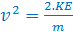 )

v = 1.91 x 10⁶ m s⁻¹ ✓

- Is it possible for a mercury atom to absorb a 10.5 eV photon? Explain briefly.
(2)
Yes, ✓ the energy above 10.43 eV will be in the form of kinetic energy of the ionised atomic electron. ✓

- Explain why the mercury atom can emit several photon wavelengths but not a continuous emission spectrum.
(3)
Line emission is possible when atomic electrons transition down the fixed energy levels of mercury, this allows several photon wavelengths to be emitted✓✓ (The atoms are well separated and independent in the vapour).  
Continuous emission occurs in (higher density) substances where energy levels overlap and a vast number of emissions occur across a spectrum of frequencies.

- The mercury atom can also emit a visible 772 nm photon. Identify the transition on the diagram with an arrow and label the transition “772 nm photon”. You must provide supporting calculations to justify your answer.
(4)
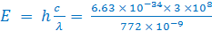 ✓= 2.57 x 10⁻¹⁹ J ✓

E (eV) = 2.57 x 10⁻¹⁹ / 1.60 x 10⁻¹⁹ = 1.61 eV ✓

Only possible transition is E5 to E4 (2.48 – 0.87) shown on diagram✓

- When UV photons strike the phosphor coating on the inside of the lamp the coating “fluoresces”. Explain this process with reference to a simple energy level diagram.
(3)
Fluorescence is when materials emit visible light as a result of absorbing electromagnetic radiation. E.g. in this context a UV photon excites atomic electrons up 2 or more energy levels.
De-excitation occurs in 2 or more steps down resulting in the emission of visible photons. ✓ ✓ Or similar.

Excitation by UV photon

Diagram ✓

Visible light emitted on de-excitation

Question 16 (9 marks)

A crane at Fremantle port is unloading an oil drum from a ship.
- The boom of the crane has a mass of 231 kg and is pivoted at point P.
- The oil drum of mass 144 kg is suspended from point B. Its rope makes an angle of 41° with the boom.
- A chain attached at point A is holding the boom in position. The distance from P to A is 3.80 m.
- The chain makes an angle of 64° with the boom.
- The boom has a length of 4.50 m from P to B with uniform mass distribution.

Point A
Boom mass
231 kg
Chain
41°
Pivot point P
64°
Point B
Oil drum mass
144 kg

- Demonstrate by calculation that the tension in the chain = 2.20 x 10³ N.
(4)
Consider boom in static equilibrium, ΣM = 0
Select pivot at P and take moments
Σacwm = Σcwm Concept ✓
3.80xF_{T}xsin 64 ✓ = (4.50x144x9.8xsin41) + (2.25x231x9.8xsin41) ✓
F_{T} = 7507.9 / (3.80 x sin 64)
F_{T} = 2198.23 = 2.20 x 10³ N ✓

- Calculate the magnitude of the reaction force acting on the boom from the pivot.
(3)
Weight = 3675 N
Tension= 2200 N
75°
Φ
Φ

Consider boom in static equilibrium, ΣF = 0
Construct vector diagram / solve by components (Concept)
θ = 180 –(41+64) = 75°
Combined weight = (231 + 144) x 9.8 = 3675 N down ✓

By Cosine Rule

✓
R = 3763 = 3.76  10³ N ✓

- Calculate the direction of the reaction force acting on the boom from the pivot.
(2)
By Sine rule 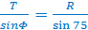

 ✓

Φ = 34.4° from vertical (or 55.6° above horizontal)
Must correspond to angle shown on diagram. ✓

A solution using components in vertical and horizontal is also possible.

Question 17 (12 marks)

A circular coil is placed in the uniform magnetic field between 2 magnetic poles such that the plane of the coil is perpendicular to the field lines. The circular coil has a diameter of 16.0 cm and is made from 150 turns of wire. The magnetic field has a flux density of 186 mT. The right edge of the coil is initially 2 cm from the limit of the field. The coil is moved to the right at a constant speed of 40 cm s⁻¹ for 0.500 seconds.

Coil is moved right at a constant 40 cm s⁻¹
16 cm
2 cm
Diagram 1

- Calculate the magnetic flux enclosed by the coil when it is fully within the magnetic field.
(2)
A = π.r² = π x (0.08)² B = 0.186 T
Φ₁ = B.A = 0.186 x π x (0.08)² ✓ = 3.74 x 10⁻³ Wb ✓

- Calculate the average value of induced emf as the coil is removed from the field
(4)
Time taken to remove coil = s / v = 0.16 /0.40 = 0.400 s ✓
Φ₂ = 0
(Note: for first 2 cm of travel the flux within the ring does not change)

emf = -N (Φ₂ - Φ₁) / t

emf = -150 (0 - 3.74 x 10⁻³ ) / 0.400 ✓
emf = 1.40 V ✓

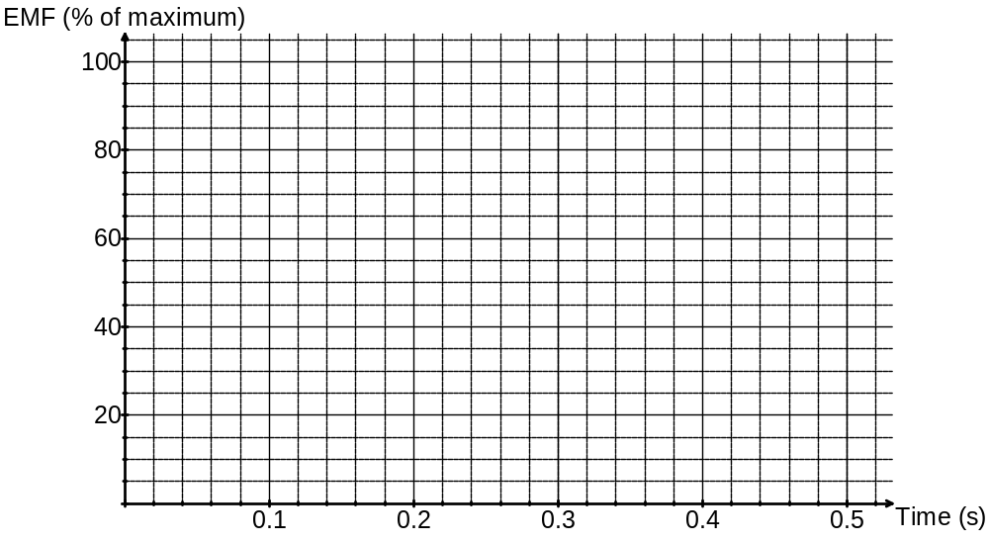

- On the graph above sketch the approximate shape of the emf versus time as the circular coil is moved right from the start position shown in diagram 1. Pay careful attention to the time axis. Briefly explain the shape of your graph.
(4)
Curve correctly sketched ✓ Explain curve features –
emf starts after 0.05 s (time taken for coil to move 2 cm right) ✓
emf is proportional to rate of change of flux within coil which increase from zero to a maximum as middle of coil exits field and then decreases back to zero. ✓
Coil is exiting field for a time of 0.400 s (s/t = 0.16/0.40). ✓

.
The diagram below shows the circular coil in the magnetic field in another experiment.

- Show the direction of induced current if the magnetic flux density increases. Draw an arrow on the coil to indicate current direction and label it ‘current’. Briefly explain your answer.
(2)
Magnetic Flux Density is increased
Current
Current is anti-clockwise ✓ According to Lenz’s law – a current will establish in a direction so that its field will oppose the change that caused. ✓ (so its field out of page opposes increase of flux into page).

Question 18 (16 marks)
Kepler-186f is a planet in orbit around the red dwarf star Kepler-186. A full public announcement about the planet was made by NASA on 17 April 2014. It is the first discovery of a planet with a similar radius to that of Earth in the habitable zone of another star.
Kepler-186f is a distance of 151 ± 18 parsecs from Earth (1 parsec = 3.26 Light Years). It has an orbital radius of 0.391 AU from its host star (The Astronomical Unit (AU) = Sun-Earth distance). It has an orbital period of 129.9 days.

- Calculate the speed of Kepler-186f around its host star
(3)
Orbital radius = 0.391 x 1.50 x 10¹¹ = 5.87 x 10¹⁰
Orbital period = 129.9 x 24 x 60 x 60 = 11 223 360 s ✓

v = 2πr / T = (2 x π x 5.87 x 10¹⁰) / 11 223 360 ✓
v = 3.28 x 10⁴ m s⁻¹ ✓

- Calculate the mass of the host star Kepler-186 based on the information given.
(4)
Orbital radius = 0.391 x 1.50 x 10¹¹ = 5.87 x 10¹⁰
Orbital period = 129.9 x 24 x 60 x 60 = 11 223 360 s
v = 3.28 x 10⁴ m s⁻¹ ✓

a_{centripetal} = v² / r = gravitational field strength = GM / r²
M = (v² x r) / G ✓
M = ((3.28 x 10⁴)² x 5.87 x 10¹⁰) / (6.67  10⁻¹¹) ✓
M = 9.48  10²⁹ kg ✓

Alternatively
derive r³ = (G.M.T² )/ 4π²
M = (r³4π²) / (6.67  10⁻¹¹  T²)

- The mass of the planet Kepler-186f is difficult to estimate and is thought to be in a range of 32% to 377% the mass of the Earth. Explain how this high degree of uncertainty affects estimates for the mass of the host star.
(2)
The equations used to calculate the mass of the host star do not use the mass of the planet e.g. M = (r³4π²) / (6.67  10⁻¹¹  T²)
or M = (v² x r) / G ✓
So this variation in mass for the planet has no effect on estimating the mass of the star ✓

- The radius of the planet Kepler-186f is 1.11 ± 0.14 times that of the Earth. Use this information and the uncertainty range for the mass of Kepler-186f to calculate the possible range for the gravitational field strength on the surface of the planet compared to “g” on Earth.
Highest value of field strength when planet radius is minimum and mass is maximum. Lowest value when radius maximum and mass minimum (concept) ✓
g = GM/r²
r (min) = 1.11 – 0.14 = 0.97R m (max) = 3.77M
r (max) = 1.11 + 0.14 = 1.25R m (min) = 0.32M

g_{maximum} = G x 3.77x M / (0.97 x R)² = 4.01g ✓
(g_{maximum} = 39.2 N kg⁻¹ if calculated)

g_{minimum} = G x 0.32 x M / (1.25 x R)² = 0.205g ✓
(g_{minimum} = 2.00 N kg⁻¹ if calculated)

(3)

- Calculate the percentage uncertainty (relative uncertainty) for the distance from Earth to Kepler-186f.
(1)
151±18 parsecs
Relative uncertainty = 18/151 = 0.119 = 11.9% ✓ (151 ±11.9%)

- The SETI institute (Search for Extra-Terrestrial Intelligence) in California started to listen to radio emissions from Kepler-186f in April 2014. As yet, no signals attributable to intelligent life have been detected. If such a signal was detected in 2014 what would be the latest year in Earth history that the signal was transmitted from Kepler-186f?
(3)
Latest transmission = shortest distance = 151 -18 = 133 parsecs ✓
133 parsecs = 133 x 3.26 Light Years = 433.58 Light Years ✓
2014 – 433.58 = the Earth year 1580 ✓

Question 19 (16 marks)

Some university students are investigating the circular magnetic field formed around a long straight wire carrying electrical current. They use a probe that measures magnetic flux density at different radii of separation from the wire.
Separation between meter and wire
Probe that measures magnetic flux density
·
Current carrying wire
The students know that the magnetic flux density decreases with increasing distance from the wire.
The students put a 90 cm straight length of wire between two clamps such that no objects (other than the probe) are closer than 40 cm to the centre of the wire.
A steady current of 2200 A is fed into the wire from an external power supply.
The probe that measures magnetic flux density is placed at set distances from the middle of the wire and measurements recorded.
The students analyse the difficulty obtaining a precise measurement of magnetic flux density and decide to record this data with an uncertainty of ±7%.
The magnetic flux density B, due to a current I, passing in a wire is given by the expression:
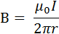
Where, = the permeability of free space (H m⁻¹), which is a measure of the extent to which the
surrounding medium reinforces the magnetic field.

r = radius of separation (m)
The results obtained are as follows:
Radius of separation  (m) | 1/r  (m⁻¹) | Magnetic Flux Density  (x 10⁻³ T)
0.065 | 15.4 | 6.70 ± 0.47
0.080 | 12.5 | 5.90 ± 0.41
0.100 | 10.0 | 4.50 ± 0.32
0.125 | 8.0 | 3.50 ± 0.25
0.200 | 5.0 | 2.10 ± 0.15
0.500 | 2.0 | 0.90 ± 0.06

Answer the following questions:

- Complete the second column of the table 1/r , so that you can plot a straight line graph.
One value has been done for you.
As table values ✓ (1)

- Complete the third column of the table (Magnetic Flux Density) to include the uncertainty for each measurement. Two values have been done for you.
As table values ✓ (1)

- Plot a graph of Magnetic Flux Density (B) on the vertical axis versus on the horizontal axis. You must include a line of best fit and error bars.

If you need to make a second attempt, spare graph paper is at the end of this question. Indicate clearly if you have used the second graph and cancel the working on the first graph.
(6)

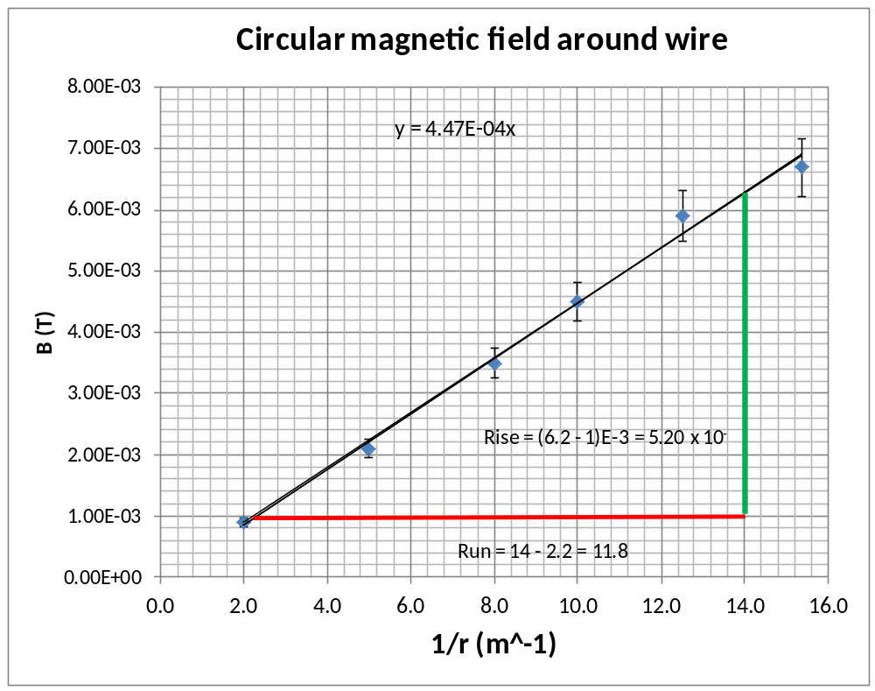

Axes labels ✓ Axes units ✓ Axes Scaling ✓ Accurate plotting ✓
Line of best fit ✓ Error bars ✓

- Calculate the gradient of your line of best fit from your graph showing all working.
(3)

Clearly show rise and run construction lines on the graph✓

gradient = 0.0052/11.8 ✓ = 4.41 x 10⁻⁴ T m ✓

- Determine the value of , the permeability of free space, from the value of the gradient that you obtained. (If you could not determine the gradient use the numerical value 4.40 x 10⁻⁴).
(3)
= 4.40 x 10⁻⁴ I = 2200 A

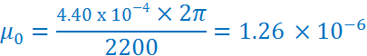

- Describe a possible source of experimental error in this experiment.
(2)
For example

The Earth’s magnetic field could be adding to the circular field being measured causing a systematic error. ✓ ✓
Or other valid point.

Spare graph paper

(3)

Question 20 (8 marks)

The diagram shows an air column that is resonating because a standing wave has formed inside it. A small microphone can slide inside the pipe without interfering with the standing wave. The microphone has detected loud regions and regions with no sound associated with this standing wave.
Loud sound
No sound
Air Column
Loud sound
No sound

- Sketch the standing wave envelope for pressure variation within this air column. ✓
(1)

- Explain briefly why there are loud regions and regions with no sound.
(2)
Sound waves are travelling along the pipe and reflecting from each end.
The standing wave is an interference pattern of the incident waves and reflected rays.
Loud spots are points of constructive interference and no sound heard at points of destructive interference. (Or similar) ✓ ✓

- The air column has an effective length of 36.0 cm. The speed of sound in air is 346 m s⁻¹. Calculate the frequency of this standing wave.
(3)
¾ λ = 0.36 m ✓
λ = 0.480 m

f = v / λ = 346 / 0.480 ✓ = 721 Hz ✓

- Calculate the frequency produced by the air column if it were vibrating in its fundamental mode.
(2)
¼ λ = 0.36 m
λ = 1.44 m

f = v / λ = 346 / 1.44 ✓ = 240 Hz ✓

End of Section 2
Section Three: Comprehension 20% (36 Marks)

This section contains two (2) questions. You must answer both questions. Write your answers in the space provided. Suggested working time for this section is 40 minutes.

Question 21 The speed of mechanical waves (18 marks)

Mechanical waves travel through material media by causing particles to vibrate. If one part of the medium is disturbed, the speed at which this disturbance is passed on depends on two properties of the medium.

Density: A denser medium has more mass per unit volume to set in motion and so responds more slowly to a disturbance. When one particle vibrates it exerts a force on its neighbours along the bonds that join them and they respond accordingly. If there is more mass to move the force will achieve a smaller acceleration.

Stiffness (Elasticity): If the bonds between the particles are stiff then disturbances between particles are transferred more effectively.

A more detailed analysis shows that in many cases:

The density and stiffness factors take different forms in different circumstance. Some examples are shown here:
Longitudinal waves in a solid rod, 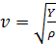 Y = Young’s Modulus (Pa), ρ=density (kg m⁻³)

Longitudinal waves in a spring, 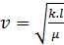 k = Spring constant (N m⁻¹), l = length (m),
μ = mass per unit length (kg m⁻¹)

Sound waves in a gas, 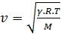 R = molar gas constant 8.314472 (J K⁻¹mol⁻¹)
T = absolute temperature kelvin (0°C = 273 K)

γ = adiabatic constant for each gas (dimensionless) (1.40 for air, 1.67 for helium, 1.30 for CO₂)

M = the molar mass in kg mol⁻¹ (e.g. air = 0.029 , helium = 0.004 , CO₂ = 0.044)

Measuring the speed of sound in a metal rod

If a metal rod is dropped vertically onto a metal plate it will bounce. The rod arrives at the metal plate and the two metals will stay in contact for the time it takes a compression pulse to travel up the rod, reflect from the top and travel back down. The returning pulse pushes the rod away from the base plate.

The rod and the base plate are made part of an electric circuit. When they make contact they trigger a high frequency electric signal (25 kHz) to be recorded on an oscilloscope until contact is broken. By analysing the number of transverse electric waves on the oscilloscope the contact time can be determined. By using this data with the length of the rod, the speed of the compression pulse can be calculated. The speed of sound in an iron rod can be deduced using this method.

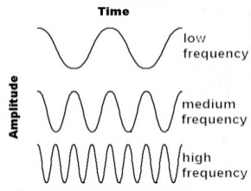
Electrical Oscillator set to 25 kHz
Oscilloscope records 7 full electrical waves from the 25 kHz source
Metal Rod
Metal Base Plate
Diagram 1
Experiment to determine the speed of sound in a Metal Rod

The rod is dropped onto the base plate

Answer the following questions

- Explain which two of Newton’s Laws are referred to in the paragraph about Density.
(2)
Newtons 1st law – inertia in relation to changing motion of more massive particles. ✓

Newtons 2nd law – a = F/m – more mass, smaller acceleration. ✓

- The passage clearly states that as material density increases then the speed of sound will decrease. How can we explain that sound travels faster in a solid compared to a gas when the solid has much higher density?
(3)
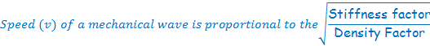
✓
So an increase in stiffness factor is having a greater effect than density increase. ✓
Newtons 2nd law – a = F/m – more mass, smaller acceleration. ✓

- Calculate the speed of sound of helium gas at 25°C (298 K) using the appropriate equation from above.
(3)
R= 8.314472, T = 298 M = 0.004 ✓
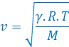
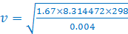 ✓
v = 1017.07 = 1.02 x 10³ m s⁻¹ ✓

- The speed of sound in Air increases with temperature. Explain what physical property of air is changing with an increase in temperature by referring to the fundamental relationship:
(2)
If temperature is increasing, the density of air is decreasing ✓

A smaller denominator gives an increased value of speed ✓

- An aluminium rod of length 80 cm and diameter 2.40 cm has a mass of 977 grams. Young’s Modulus for aluminium is 70 x10⁹ Pa. Calculate the speed of sound in this aluminium rod using the appropriate formula.
(4)

80 cm

Density = mass / volume = mass / ✓
Density = 0.977/) = 2699.56 kg m⁻³ ✓

. 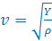 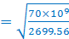 = 5.09 x 10³ m s⁻¹ ✓

- For the experiment to determine the speed of sound in a metal rod, a speed of 5200 m s⁻¹ was determined for a steel rod. Calculate the length of the steel rod if 7 full waves were recorded on the oscilloscope. (Refer to Diagram 1).
(4)
v = 5200 m s⁻¹, f = 25,000 Hz so T = 1/25,000 = 0.00004 ✓
So the time for 7 waves = 7 x 0.00004 = 2.80 x 10⁻⁴ s ✓

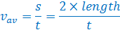

✓
Length = 7.28 x 10⁻¹ m ✓

Question 22 Einstein’s theory of Special Relativity – Time Dilation (18 marks)

Imagine that you are a stationary observer and your friend flies away from you in a spaceship at 2.00 × 10⁸ m s⁻¹. You then shine a laser beam at your friend’s spaceship. The laser beam travels towards the spaceship at 3.00 × 10⁸ m s⁻¹. Using simple arithmetic you think that the light is travelling towards the spaceship at a net velocity of 1.00 × 10⁸ m s⁻¹. But the principle of relativity says that if your friend measures the speed of the laser beam from her spaceship she sees it travelling at 3.00 × 10⁸ m s⁻¹ relative to her. This raises an important question.
Planet Earth

Spaceship travels at 2 x 10⁸ m/s away from Earth
Laser beam follows
Spaceship at 3 x 10⁸ m/s

How can the light gain 1.00 × 10⁸ m s⁻¹ towards the spaceship as measured by you but be travelling at 3.00 × 10⁸ m s⁻¹ relative to the spaceship as measured by your friend on the spaceship? The answer is it can do both if your friend’s seconds last longer than yours.

In special relativity, moving clocks run slow in the sense that the observed time between ticks is taking more time. The rate that time passes is taking longer.

The speed of light in a vacuum does not vary when viewed by any observer travelling at any speed. If Einstein’s theory of special relativity is correct then time runs slower for moving objects compared to the time duration experienced by stationary observers.
t_{v} = time between “clock ticks” on a moving object

t₀ = time between “clock ticks” in stationary reference frame
The units of time are arbitrary but must be the same for t and t₀

v = the speed of moving object (m s⁻¹)

c = speed of light in a vacuum (m s⁻¹)
Time dilation can be calculated using the formula:

Where γ is the time dilation factor given by:

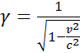

The slowing of time has been tested by NASA by comparing 2 identical atomic clocks. One was left on Earth and the other sent into high speed orbits around Earth. The time that passed for the orbiting clock was less than that of the Earth based clock.

This principle clashes with many peoples common sense views of the world they live in and is often illustrated with the Twin Paradox.

Two identical twins celebrate their 21st birthday on Earth. The girl leaps into a space ship for a trip around the stars at speeds that give her a time dilation factor (γ) of 10. Her brother remains on Earth and sees her return in 20 years time when he is 41 years old. When she steps out of the spaceship she is only 23 years old.

The paradox is that the travelling twin argues that if she observes from her frame of reference then her brother should age less on Earth. (She argues that relative to her, the earth moved away from her at the same speeds). However, she is incorrect as her reference frame is not the same as the brother on Earth for the whole journey as she experiences accelerations and decelerations. These periods of non-inertial motion are the key to the difference in the frames of reference. This is explained fully in the General Theory of Relativity.
- A spaceship is travelling directly towards the Sun at 1.40 × 10⁸ m s⁻¹. Light is travelling from the Sun towards the spaceship at 3.00 × 10⁸ m s⁻¹. What is the speed of light from the Sun relative to a pilot on the spaceship?
(1)
c = 3 x 10⁸ m s⁻¹ ✓

- A spaceship travels away from Earth at 85% of the speed of light. A NASA technician on Earth calculates that ship will travel for 8 years at this speed. Calculate how much time will elapse on the spaceship as viewed from Earth. Give your answer in years to 2 decimal places.
(4)
v = 0.85c
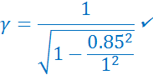

time (moving object) = rest time / 1.8983
time (moving object) = 8 / 1.8983✓
time (moving object) = 4.21 years ✓

- Determine what happens to the magnitude of the time dilation factor (γ) as v approaches the speed of light?
(2)
let v = c
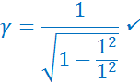
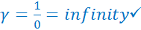 (so approaches infinity)

- What happens to time inside a spaceship (as viewed from Earth) if the speed of the spaceship relative to the Earth approaches the speed of light?
(2)
As the time between ticks approaches infinity ✓ then time stops on the moving object ✓

- Does Einstein’s theory of special relativity allow for objects to travel faster than the speed of light? Justify your answer by making reference to the time dilation factor (γ).
(3)
If v > c then v²/c² >1 and 1 minus a number greater than 1 is negative. ✓

The square root of a negative number is not real ✓so the time dilation factor cannot be calculated. ✓

- Determine the speed a spaceship must travel such that 23 years of time passes on the moving spaceship whilst 230 years passes for an observer on Earth.
(4)
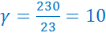 ✓
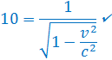
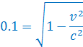
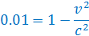
(manipulation of algebra) ✓

✓

- In the twin paradox why is it incorrect for the girl to state that her brother should age at a slower rate than her? All motion is relative and she argues that from her frame of reference she was stationary and everything else moved.
(2)
Her reference frame is not the same as the brother on Earth for the whole journey as she experiences accelerations and decelerations. ✓
These periods of non-inertial motion are the key to the difference in the frames of reference. ✓

Her reference frame is not the same as the brother on Earth for the whole journey as she experiences accelerations and decelerations. ✓
These periods of non-inertial motion are the key to the difference in the frames of reference. ✓

End of questions

Additional working space

Additional working space

Additional working space

End of examination

